CBOE
Test Plan
PITS 39320
SEDL 9025
The following test cases assume that user DVS’s firm is 549 and user NYM’s firm is 551.

Test Case 1: Verify that ETN Timeout is sent to OMT when property is set to Y at Firm Level

Firm Property Setup:
- Define ‘Firm Electronic Trade Notification Parameter’ to Y at the firm level for user DVS.
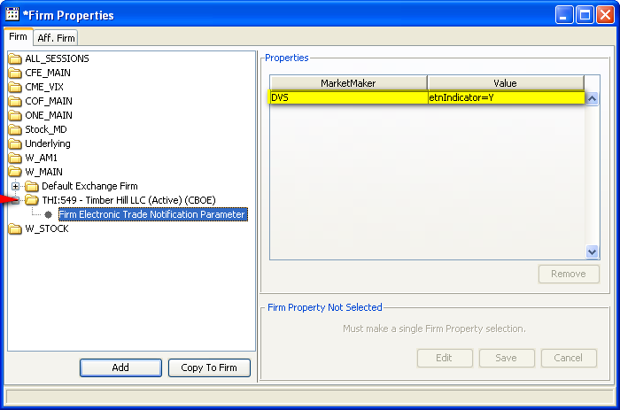

- Define a Crowd Default OMT Destination for your Market Maker User. In this case user NYM’s firm is 551 so we defined the default destination here
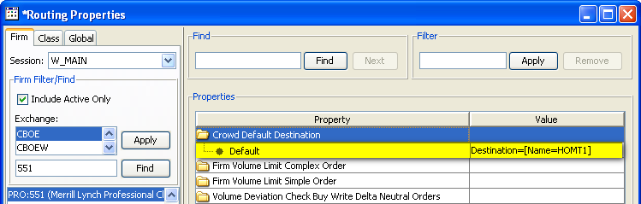

Workstation Setup:
- Define and login to a PAR workstation
- Login to the crowd OMT using the user defined above as crowd default location.
- Login to a separate Trader GUI using the market maker NYM to route order from CBOEdirect to the PAR workstation.

  - Login to your OMT as user HOMT1 (or the user defined in the crowd default destination above)
  - Open the OMT Message Window
  - Route order AAPL Buy 100@1.20 using your Market Maker Trader GUI
  - Fill Order on PAR with user DVS. Verify that the Firm number in PAR matches the firm number in User Maintenance for the user DVS.
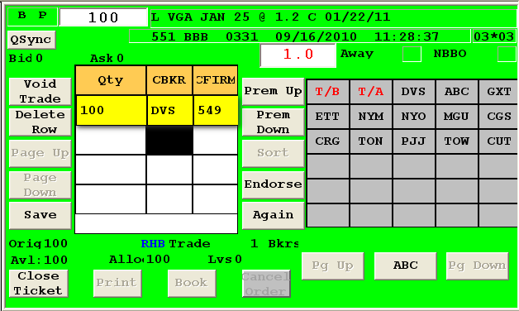

Verification:
- After 60 secs, verify Trade Notification Timeout is received at the OMT.
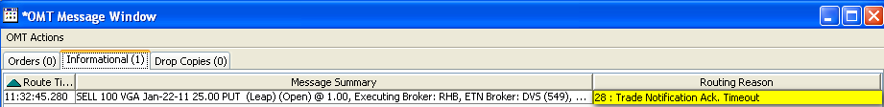

Test Case 2: Verify that ETN Timeout is sent to OMT when property is set to Y at Default Level

Firm Property Setup:
- Delete existing ‘Firm Electronic Trade Notification Parameter’ added from test case 1 from the Firm Level
- Define ‘Firm Electronic Trade Notification Parameter’ to Y at the firm level for user DVS.
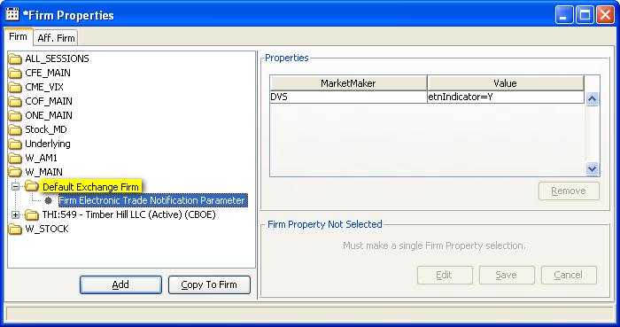

- Define a Crowd Default OMT Destination for your Market Maker User. In this case user NYM’s firm is 551 so we defined the default destination here

Workstation Setup:
- Define and login to a PAR workstation
- Login to the crowd OMT using the user defined above as crowd default location.
- Login to a separate Trader GUI using the market maker NYM to route order from CBOEdirect to the PAR workstation.

  - Login to your OMT as user HOMT1 (or the user defined in the crowd default destination above)
  - Open the OMT Message Window
  - Route order AAPL Buy 100@1.20 using your Market Maker Trader GUI
  - Fill Order on PAR with user DVS. Verify that the Firm number in PAR matches the firm number in User Maintenance for the user DVS.

Verification:
- After 60 secs, verify Trade Notification Timeout is received at the OMT.

Test Case 3: Verify that ETN Timeout is NOT sent to OMT when no property is found

Firm Property Setup:
- Delete existing ‘Firm Electronic Trade Notification Parameter’ property at both Default and Firm Levels for user DVS.

- Define a Crowd Default OMT Destination for your Market Maker User. In this case user NYM’s firm is 551 so we defined the default destination here

Workstation Setup:
- Define and login to a PAR workstation
- Login to the crowd OMT using the user defined above as crowd default location.
- Login to a separate Trader GUI using the market maker NYM to route order from CBOEdirect to the PAR workstation.

  - Login to your OMT as user HOMT1 (or the user defined in the crowd default destination above)
  - Open the OMT Message Window
  - Route order AAPL Buy 100@1.20 using your Market Maker Trader GUI
  - Fill Order on PAR with user DVS. Verify that the Firm number in PAR matches the firm number in User Maintenance for the user DVS.

Verification:
- After 60 secs, verify Trade Notification Timeout has not been sent to the OMT.

